Night Time Blitz Experience Workshop

Hello, thanks for taking the time to look at this, my name is Leon, and I am an artist and musician that performs under the name Secondson. I’m making work for a commemorative performance on Corporation Road, on January 2nd, 2021 - The 80th anniversary of the Grangetown blitz.

1. What is the Blitz?
Visit these links to find out more; Link 1 link 2 link 3

2. Grangetown was one of the areas hit by the bombing; you might live here. Can you circle Grangetown on this map?

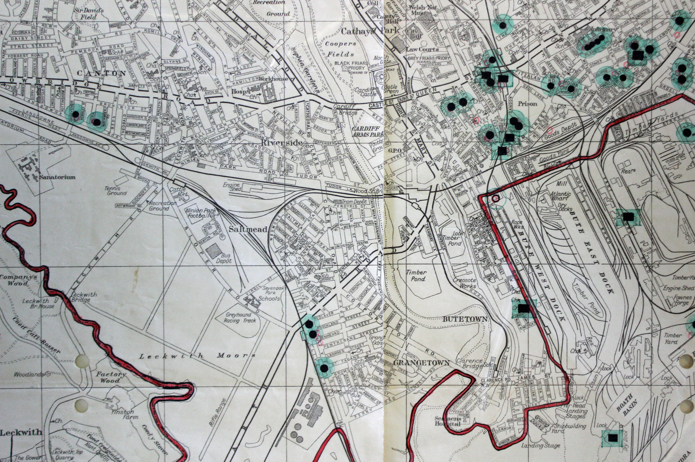

3. These are the sites in Grangetown that were involved in the blitz of January 2nd, 1941. Do you live close to any of these? Put a cross where you live on the Map above.

4. Does your house have a cellar? It’s possible people could have sheltered in there during the war. Some houses also had Anderson shelters in their gardens. Could you find how they looked and find out if there was one in your garden?

Draw a picture of what your blitz shelter would look like. What would you put in it?

5. If you could ask someone who had been in the blitz anything about it what would you ask ? Answer here:
6. Could you imagine how you would feel if we were at war now? In what ways do you think being at war would change your day to day life, what would be different for you?

Think about the things you have, where you go with your friends and even the things you eat. Do you think there would be a big change for you?

Write one thing that would be different for you:

7. Have you ever found the plaque on Clarence Hardware on Corporation Road and do you know why it is there? It looks like this;
8. If I asked you what a Heinkel HE111 is, what can you find out about it? Could you draw it for me in black ink on a sheet of white paper or even on a program on your computer? (Maybe I could use your drawings as part of my performance on the night).

9. As part of my performance, I will be using a halldorophone, it is a rare instrument that creates loud feedback and drones. Do you know what a drone sounds like? Do you think you have anything at home that sounds like a drone? Do you have a way of recording that sound for me?

To give you a clue, nearly every home has one piece of equipment that definitely creates a drone sound, it is used for housekeeping. Could you research the halldorophone and tell me why it has that name, and what country does the inventor come from?
10. This is the billboard where I am making my work, from what you’ve learnt in this workshop what would you project/print on them? Draw on the picture below:

